Hai Nguyen

CPSC 323

Professor Anthony Le

September 20, 2019

**Assignment 1 (Lexical Analyzer) Documentation**

Operating System: Windows 10

Language: C++ (Visual Studio 2017)

Description: this program lets the user input a source code file name, analyze the file, and print the tokens and lexemes lists to the “analysis.txt” file.

**1. Problem Statement:**

Build a lexical analyzer using a FSM.

**2. How to use the program:**

- User enters a source code file name

- The program will print out the tokens-lexemes list on the console screen and also prints the result to “analysis.txt” file

**3. Design of the program**:

This program has a LexicalAnalyzer class. This class reads a source code file and store the tokens in tokens vector and lexemes vector.

Regular Expressions and NFSMs:

Inputs: l (letter), d (digit), $, p (point ‘.’)

Integer: d+

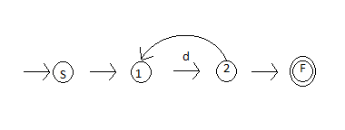

Identifier: l ∙ (l | d | $)*

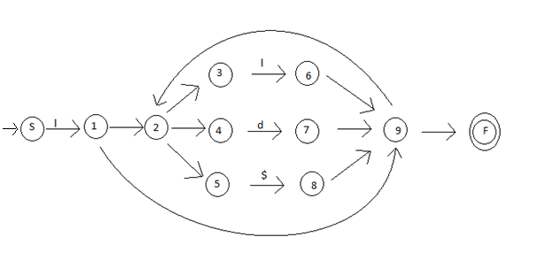

Real number: (p ∙ d+) | (d+ ∙ p ∙ d*)

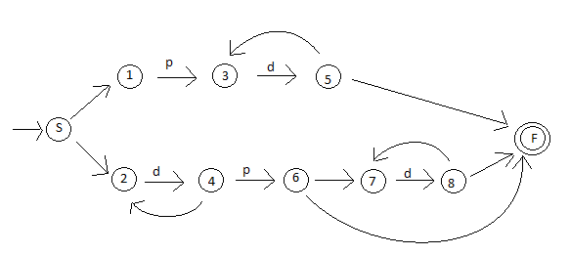

**4. Any Limitation:**

None

**5. Any Shortcomings:**

None

**6. Test cases:**

Case 1:

Source code:

while (fahr < upper) a = 23.00 whileend

Output:

TOKENS LEXEMES

keyword while

separator (

identifier fahr

operator <

identifier upper

separator )

identifier a

operator =

real 23.00

keyword whileend

Case 2:

Source code:

! Find largest value between two numbers!

int num1, num2, large$

if(num1 > num2)

{

large = num1$;

}

else

{

large = num2$;

}

Output:

TOKENS LEXEMES

keyword int

identifier num1

separator ,

identifier num2

separator ,

identifier large$

keyword if

separator (

identifier num1

operator >

identifier num2

separator )

separator {

identifier large

operator =

identifier num1$

separator ;

separator }

keyword else

separator {

identifier large

operator =

identifier num2$

separator ;

separator }

Case 3:

Source code:

int a = -1;

print(a * 5.1);

Output:

TOKENS LEXEMES

keyword int

identifier a

operator =

operator -

int 1

separator ;

identifier print

separator (

identifier a

operator *

real 5.1

separator )

separator ;